**HTML**

[Hyper Text Markup Language]

* **What is Hyper Text?**
  + Hyper is a Greek Term, which means “beyond”
  + Hyper Text means, some text that provides content beyond what you see.
* **What is Markup?**
  + Markup is a general computing term, which is derived from a concept called “Markingup”.
  + Markup means preparing for presentation.
  + HTML is a language used for presentation.
  + HTML is used for presenting on Printer, Screen [any device that is from a mobile to pc].

**Evolution of HTML**

* Internet started with a Browser called “Mosaic”.
* The languages used for presentation were GML [Generic Markup Language] and SGML [Standard Generic Markup Language].
* **Tim Berners Lee** introduced the concept of **Web.**
* **Tim Berners Lee introduced a language for Web called “HTML” in 1993.**
* **HTML** is superset to SGML.
* **IETF [**Internet Engineering Task Force] took the responsibility of developing HTML.
* **W3C [**World Wide Web Consortium] **and WHATWG [**Web Hypertext Application Technology Working Group] maintained standard of HTML and developed further versions.

|  |  |
| --- | --- |
| **HTML Version** | **Year** |
| HTML 2 | November 24, 1995 [**IETF]**   * Form base “file upload” * Tables * Client-Side Image Maps * Internationalization |
| HTML 3 | January 14, 1997 **[W3C]**   * Several feature for design for a browser called Netscape. * Blinking * Marquee * MathML |
| HTML 4 | December 18, 1997 [**W3C]**   * Transition elements * Frameset and Frame * Browser specific elements * Multimedia |
| HTML 5 | October 28, 2014 [**W3C – WHATWG]**  May 27, 2019 **HTML 5.2** latest |

**Browser Object Model [BOM] & Document Object Model [DOM]**

* HTML presents content by using a set of elements.
* An element includes Image, Table, Form, Paragraph etc.
* HTML elements are arranged in a hierarchy called **DOM.**
* **DOM** is a part of **BOM.**

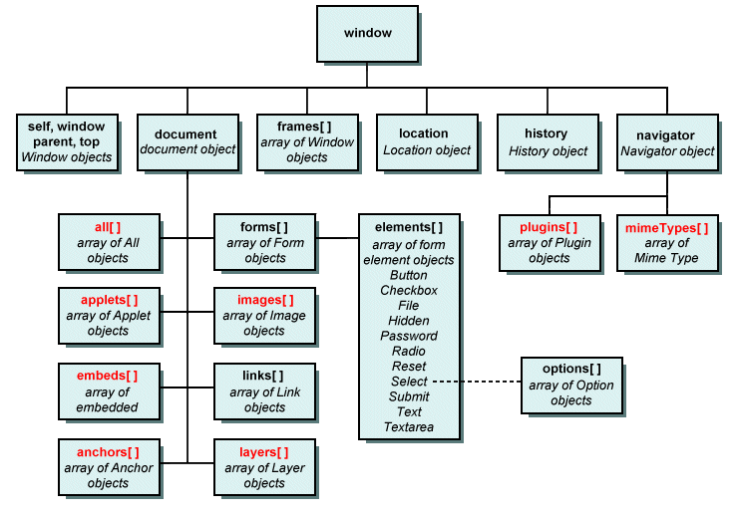

* HTML is a set of elements, which are categorized into 5 different groups
  + **Normal Elements**
  + **Void Elements**
  + **RC Data Elements**
  + **Raw Text Elements**
  + **Foreign Elements**
* Elements are presented by using “Tag”

**Element Tag**

Image <img>

Anchor <a>

|  |  |
| --- | --- |
| **Element Type** | **Description** |
| Normal Element | * A normal element can return any presentation directly on call back. It doesn’t require any additional attribute for presentation. * A normal element starts returning presentation but can’t stop implicitly. * You have to always stop the element presentation explicitly. * Hence a normal element requires both start and end tag. * <start> </end>   **Ex: <b> </b>** |
| Void Element | * Terms void refers to no return type. * A void element in HTML can’t return any presentation directly on call back. * It requires additional attribute for presentation. * It presents what you have specified and then stop. * Void element doesn’t require and End tag. * Void element is self-ending element.   **Ex:**  **<img>** |
| RC Data Element | * Rich Text Content Element * It is an element used for presenting only text. * It will not allow any another element within the context.   **Ex:**  <textarea> </textarea> |
| Raw Text Element | * It is an HTML element, which can present without using a tag. * It refers to raw text with &, >, <   Ex:  &copy;  &#8377; |
| Foreign Element | * It is used in HTML but not native to HTML. * It requires additional library.   **Ex:**  **SVG, Canvas, MathML** |